**User Guide**

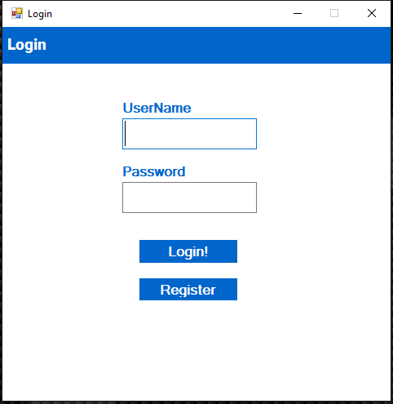Press register to create an account, if you already have an account please enter your details and login.

Registration

Once all of your details are filled in press submit, you will automatically be logged in.

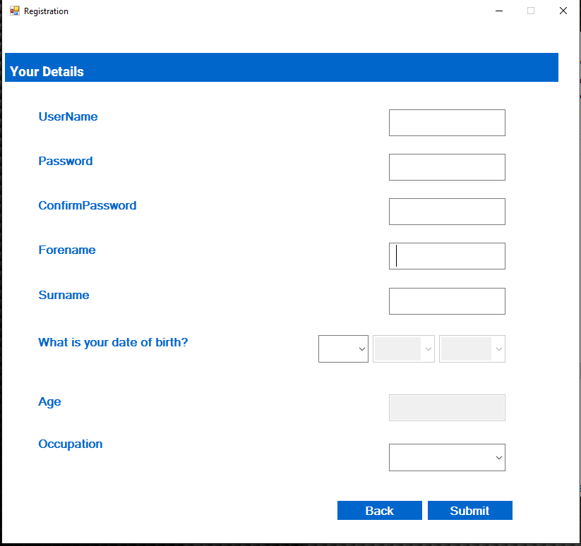

At first the Main Menu will be disabled, to enable first select a policy start date:

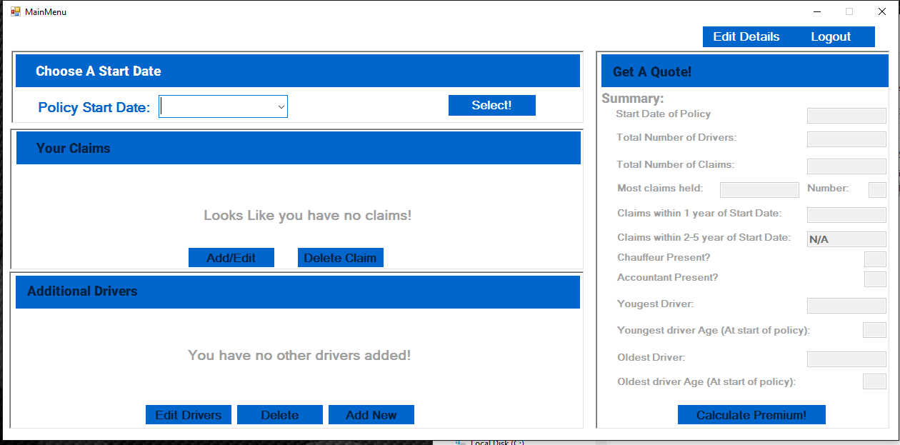

Once a Start date has been selected press the select button and your details will be populated.

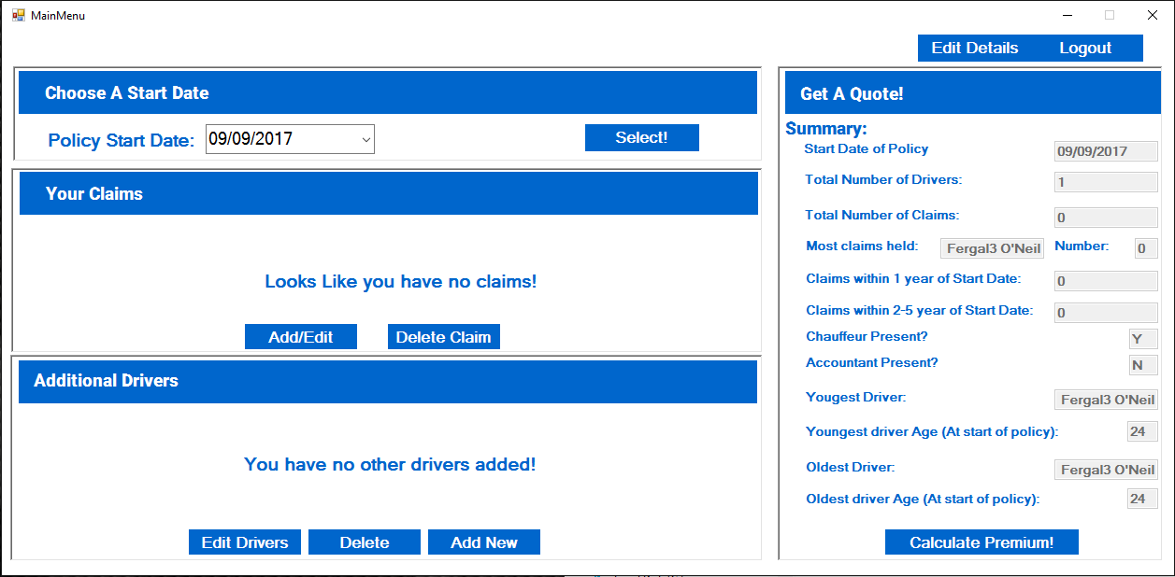

The "Your Claims" section of the menu allows the user to add claims that they are responsible for. To add a claim click the "Add/Edit" button. Once done you will be taken to the Main Claims Screen.

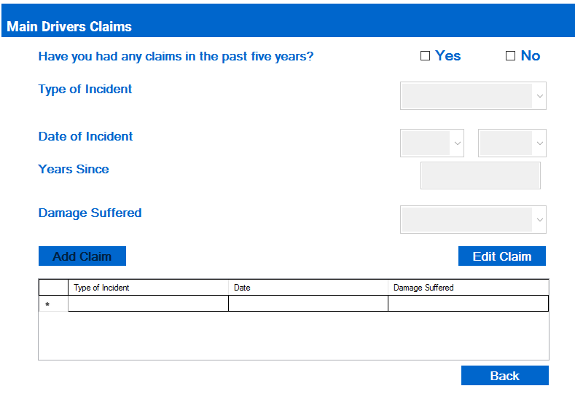

It is from here that you can add any claims that you may have. To add a claim check the "yes box" at the top to enable the form.

The "Second Drivers" section of the menu allows the user to add second drivers and the claims claims that they are responsible for. The form will only allow the user to add claims once they have added a driver. The add claims section of this form is similar to the "Main Claims" form.

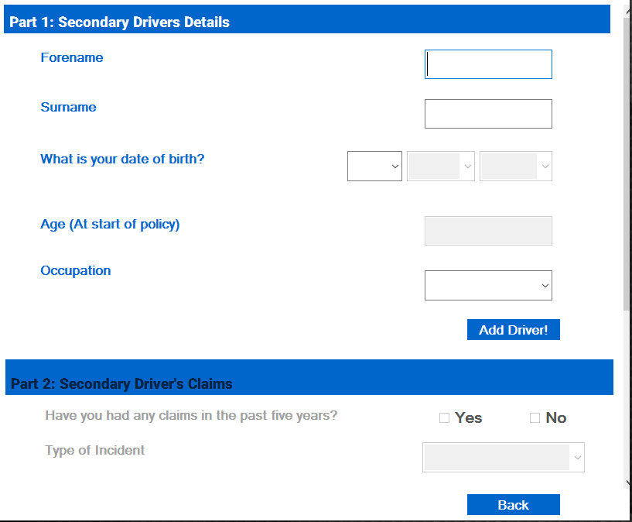

The "Get a Quote" Section will show you a summary of your policy so far, once you are happy with your policy click the "Calculate Premium" button:

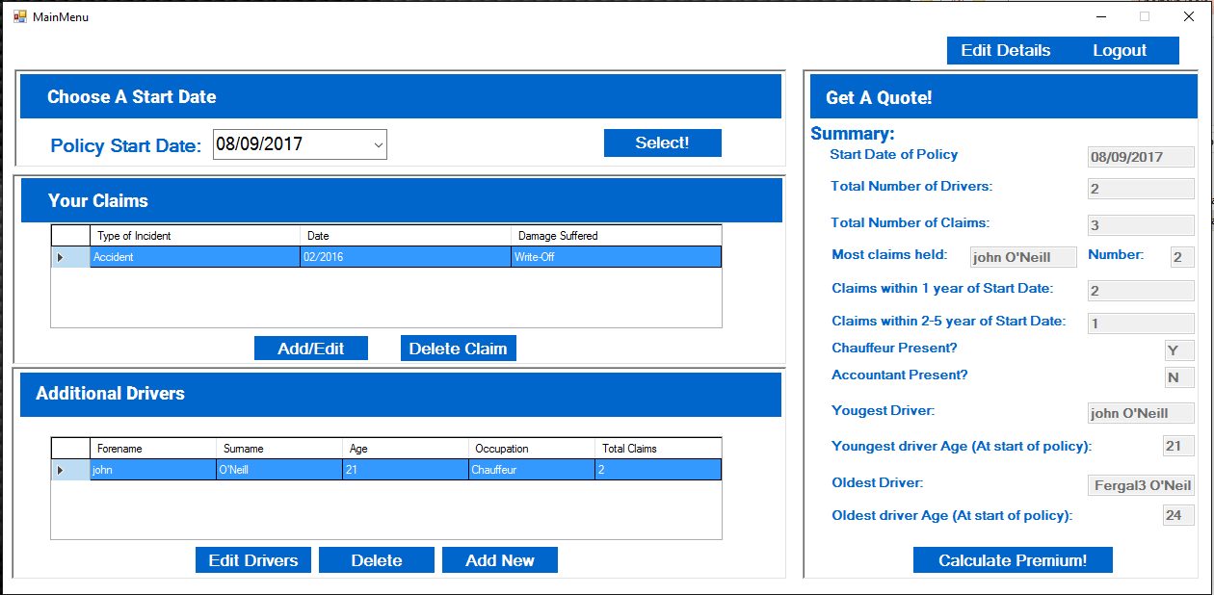

The calculator will generate a quote as show below:

